

Solution Design Document



Corna Virus Statics PROCESS

Revision History
Rev. # | Date | Section/Page# | Revision Summary | Author
1 | 10/09/2025 | All | Created first version | Constantin Dumitrascu
2
3
4

​​

Contents
I. PURPOSE 3
II. AUTOMATED PROCESS DETAILS 3
Summary 3
III. RUNTIME GUIDE 4
1. Architectural structure of the Master Project 4
2. Master Project Runtime Details 5
3. VendorDispatcher 6
4. VendorPerformer 6
5. Project(s) workflows 7
6. Packages 7
7. Assets 7
8. Exceptions 7
9. REPORTING 8
10. Security 8
11. Compliance Considerations 8
IV. OTHER DETAILS 9
V. GLOSSARY 9

​​

I. PURPOSE
Outlines the major components of the Master Project (the overall output of the development, containing one or multiple projects that together cover the scope of the robotic process automation) taking into account all the business restrictions (scheduling, peaks, future increases in volume etc.). The focus of the Solution Architect will be on:
- Robustness
- Scalability
- Efficiency
- Replicability
- Reusability of components
The information herein is targeted primarily at the developers that will initially implement the solution and subsequently at the support developers in case of change requests.
The automation solution will utilize the RE Framework with a single Performer model. The Performer will be responsible for executing the end-to-end workflow: capturing user input, retrieving the requested country’s COVID-19 statistics from the web, validating and formatting the data, and saving it into a structured text file at the specified location .

II. AUTOMATED PROCESS DETAILS
Details filled in need to reflect the actual information for the Master Project released for production. The following table will be populated:

Item | Description
Master Project Name | COVID-19 Statistics Extraction and Reporting Process
Robot Type | attended (needs user input to determine Country name and output path)
Orchestrator used? | Yes – for scheduling, monitoring, and centralized logging
Scalable | Yes
UiPath version used | 2025.0.172

Summary
The process retrieves COVID-19 statistics for a user-specified country, formats the extracted data, and saves it in a structured text file for reporting.
From a technical perspective, the process will be executed as a single package but logically split into two subprocesses:
- Data Retrieval Subprocess – takes user input, launches the browser, searches for the selected country’s statistics, and extracts the numbers (cases, deaths, recovered).
- Data Formatting & Storage Subprocess – opens Notepad, applies the required font style, writes the extracted data, and saves it to the specified file path.
The package ensures all applications are closed at the end of the process, with exception handling in place for both business and application errors
:

III. RUNTIME GUIDE

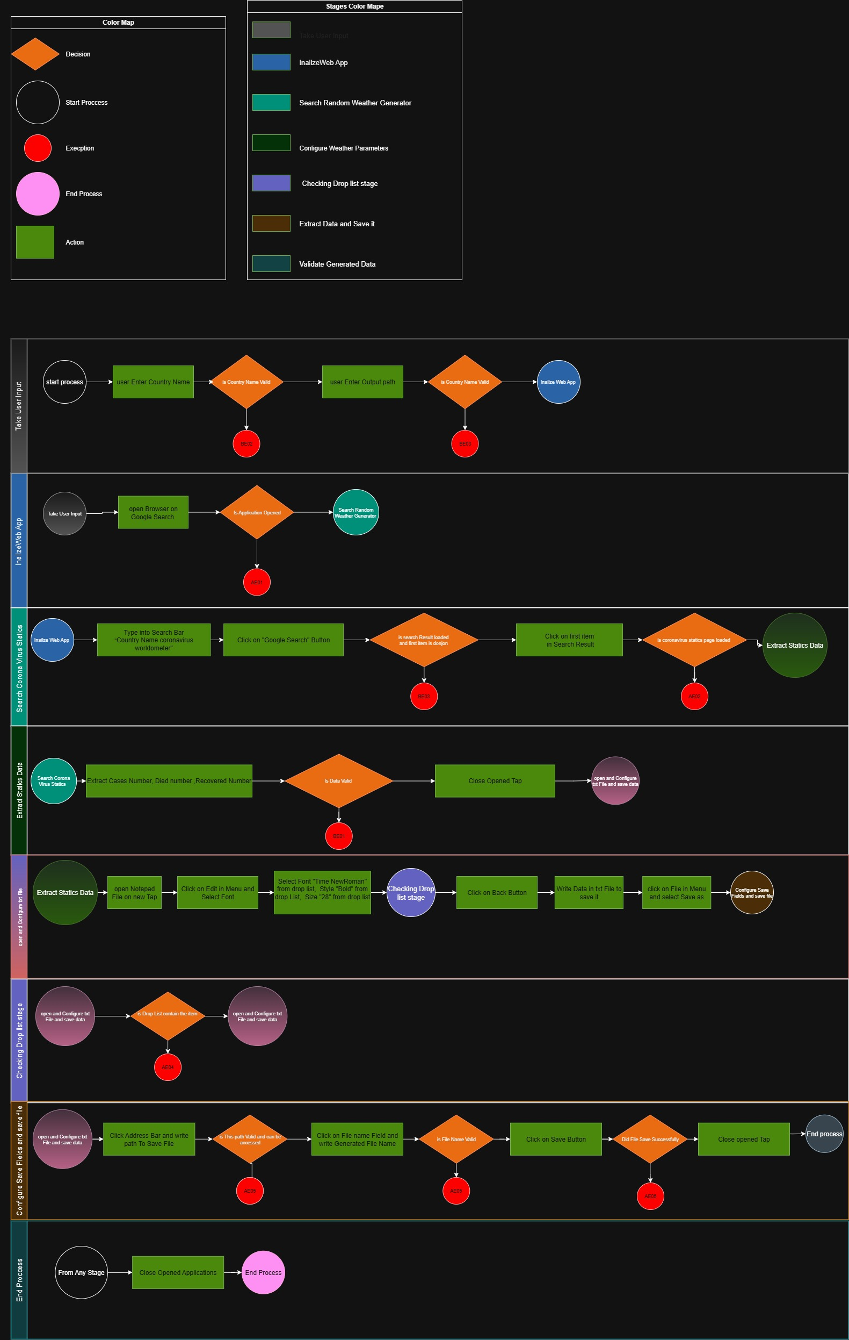
Architectural structure of the Master Project

Master Project Runtime Details
Outlines the details of the automated process by filling in the table below.
ITEM NAME | DESCRIPTION  Fill in each bolded section - empty fields are not allowed. If the section does not apply to your automation then mark as n/a.
Production environment details | Windows 10/11, UiPath Robot installed
Prerequisites to run | Dispatcher: Chrome, Excel, Acrobat  Performer: Chrome, Excel, Acrobat
Input Data | User-provided country name and output file save location
Expected output | Formatted text file containing COVID-19 statistics (cases, deaths, recovered) for the specified country
How to start the automated process | Time-based trigger in Orchestrator or manual trigger from UiPath Assistant
Reporting  (queues reporting, Kibana or another platform) | Orchestrator logs; process execution reports available through UiPath Orchestrator
How is Orchestrator used? | Orchestrator used for scheduling, logging, monitoring, and retry management
Password policies  (mention any specific compliance requests) | n/a
Stored credentials
(Never use hardcoded credentials in the workflow!)

List of queues names
(Naming convention: ProcessName_QueueName)
Schedule Details | Daily scheduled run, with option for ad-hoc execution
Multiple Resolutions Supported?  (in case of image automation / Citrix and VDI) | n/a (process interacts directly with applications)
Recommended Resolution | n/a

Project(s) workflows
TO BE ADDED AFTER DEVELOPMENT

Workflow Name | Description
Example: Main | Example: invokes all the other workflows

Packages
Include the list of packages and high-level description for each of them, to explain their purpose
Package Name | Description
UiPath.System.Activities
UiPath.UIAutomation.Activities

Exceptions
During the process run, certain scenarios might arise that the robot cannot process and will require manual intervention. These are defined as exceptions. Below are the two types of exceptions:
Business Exceptions – A business logic error or missing data which is encountered on a daily basis by the business unit. There is a clear workaround that can be resolved by reviewing the case.
Application Exceptions – This is defined as an unexpected error encountered by the robot such as a network error or an application error which is outside the control of the business unit and will need to be resolved by IT or the RPA team
# | Exception description | Action to be taken
AE01 | Web browser fails to open Google Search | Retry opening up to 3 times; if still failing, log error and notify IT/ Analytical office
AE02 | coronavirus statics page does not load or times out | Refresh page, retry up to 3 times; if still failing, log issue and escalate to IT
AE03 | Notepad fails to open | Retry opening Notepad up to 3 times; if still failing, log error and notify IT support
AE04 | Dropdown menus (Font, Style, Font Size) fail to populate or become unresponsive | Close Notepad and open it again, retry 3 times; if issue persists, log as UI failure and escalate to IT
AE05 | Error occurs while saving file (invalid path, access denied, or file name issue) | Prompt user for correct file path/name; if issue persists, log error and notify IT support

REPORTING
MIS report

Testing
Testing is an essential part of any development process. Its main purpose is to ensure the automated process is functioning in the way it is supposed to. By beginning the testing process during development, any issues, bugs, and errors can be identified and potentially corrected at the earliest possible opportunity.
Each level of testing is responsible for different parts of the automated solution, reassuring high quality of each of the elements delivered. Each of the stages must be completed before the solution is released to the production environment.
The stages of testing are:
Unit Testing - Focuses on the individual components and workflows created specifically for the process in scope, assessing whether they function as according to the original design.
Responsibility: Development Team
System Integration Testing – Ensuring all required functionalities, both business and technical, are implemented, as well as ensure unit testing has been completed successfully, development Best Practices have been applied and code review has been completed by a Solution Architect. There will usually be a round of fixes to be implemented before the automation can proceed further.
Responsibility: Dedicated tester / Solution Architect
User Acceptance Testing – Process team take responsibility of this phase of testing to ensure they are happy with the results of the automated business process. Sign-off of this phase is business led and mandatory in order to proceed further. Generally, there will be iterative fixes to be implemented that have been discovered during the user testing of the automation.
Responsibility: Dedicated tester & Business Unit
Pre-Production Testing – Validates the readiness of the product prior to Production deployment.
Responsibility: Dedicated tester, Development Team & Solution Architect
Dry-Run –Monitor the initial cases run by the process to account for any environmental differences between Pre-Production and Production.
Responsibility: RPA Business Analyst & Business Unit

Security
Security is a vital aspect of digital processes as it provides an extra layer of protection from the public. There are different ways in which security is implemented when automating an existing process, some of which are discussed in this section.
Sensitive data such as passwords and client/customer information (like information stored in databases) must never be unnecessarily stored outside of its origin application when handled by the RPA solution.
Similarly, user and application credentials used by the RPA solution must also never be unnecessarily stored or shared with any unauthorized persons. In addition to that, if the robot is dealing with password reset policies that are internal to the client, those policies must be followed to ensure security is maintained.
API keys are often used within RPA solutions to allow access to certain applications, and these are ideally stored in Orchestrator credential assets and only accessed when needed. As with credentials, they should never be shared or stored elsewhere.

Compliance Considerations
Display the interaction between components (package / robots, Orchestrator queues, and running order) in a diagram.
Item | Specific Considerations (use N/A if not applicable)
Sarbanes Oxley (SOX) | n/a
HIPAA | Orchestrator approved for storing confidential information (in queue items).  Do not store PII or PHI to Logs.
FERC Standards of Conduct | n/a
Personally Identifiable Information (ensure process follows PoLP) | Orchestrator approved for storing confidential information (in queue items).  Do not store PII or PHI to Logs.
Others

IV. OTHER DETAILS
Future Improvements
Fill in any improvements that need to be considered for the future:

Other Remarks
Please mention here any other points that you consider relevant for the automation process.

V. GLOSSARY

The main terms used in the Solution Architecture Document are defined below:
Master project - the overall output of the development, containing one or multiple projects that together cover the scope of the robotic process automation. There is a 1 to 1 connection between the Master Project and the Process to be automated (As presented in the PDD).
Project - an UiPath Studio project containing one or multiple workflow files. A project can be converted to a package and run independently, covering a particular scope within the master project. Or multiple projects can be converted into one package depending on the aims and restrictions of the automation. The project is used when defining the development and support phase of the automation.
Package - the output of compiling one or multiple projects. A package can be deployed on the robot machine and be executed by the robot service. Only one package can be executed at a given time by a robot. The package is used when defining the running phase of the automation.
Workflow - a component of the package, the workflow encapsulates a part of the project logic. The workflow can be of type: sequence, flowchart or state machine. A workflow is saved as an .xaml file inside the project folder. A workflow file can be invoked from another workflow and by default there is an initial workflow file that will run when executing the package.
Activity - an action that the robot executes.
Sequence - a workflow where activities are executed one after another, in a sequential order
Flowchart - a workflow where activities are connected by arrows and the logic of the workflow can be easily followed in a visual manner. The flowchart can also be exported as an image from UiPath studio.
State machine - a more advanced way of organizing a workflow, similar to a flowchart.
BOR - Back office robot
FOR – Front office robot
Orchestrator – Enterprise architecture server platform supporting: release management, centralized logging, reporting, auditing and monitoring tools, remote control, centralized scheduling, queue/robot workload management, assets management.

